|  |  |
| --- | --- |
| **Name** | Adit Verma |
| **Roll Number** | K062 |

**Screenshots**

**Msfconsole**

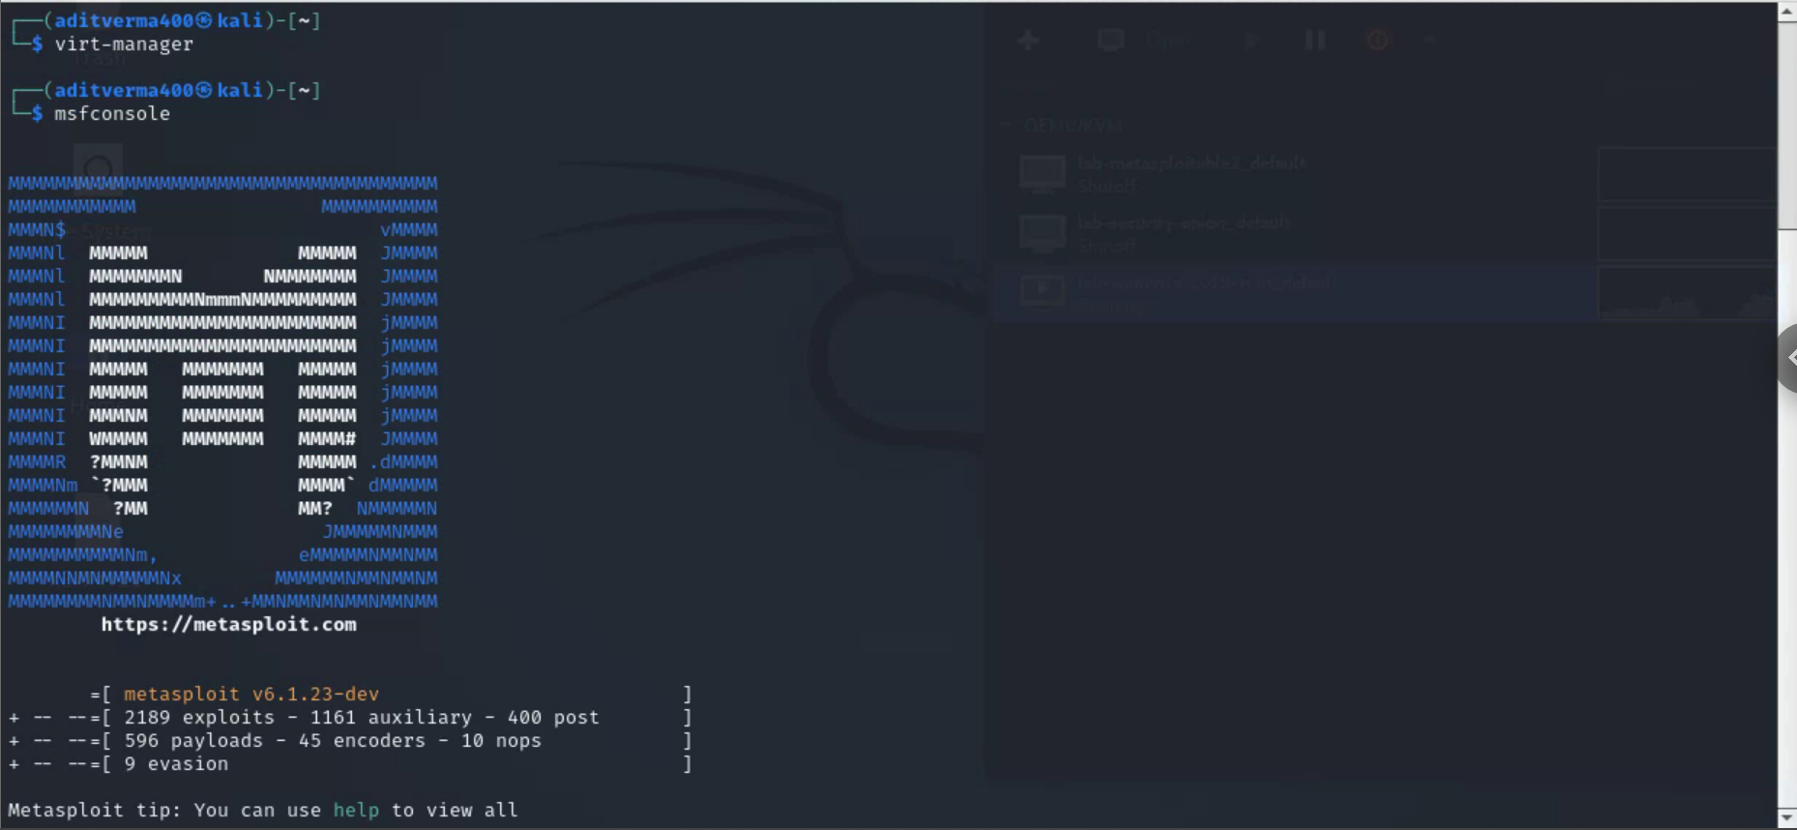

**Windows VM**

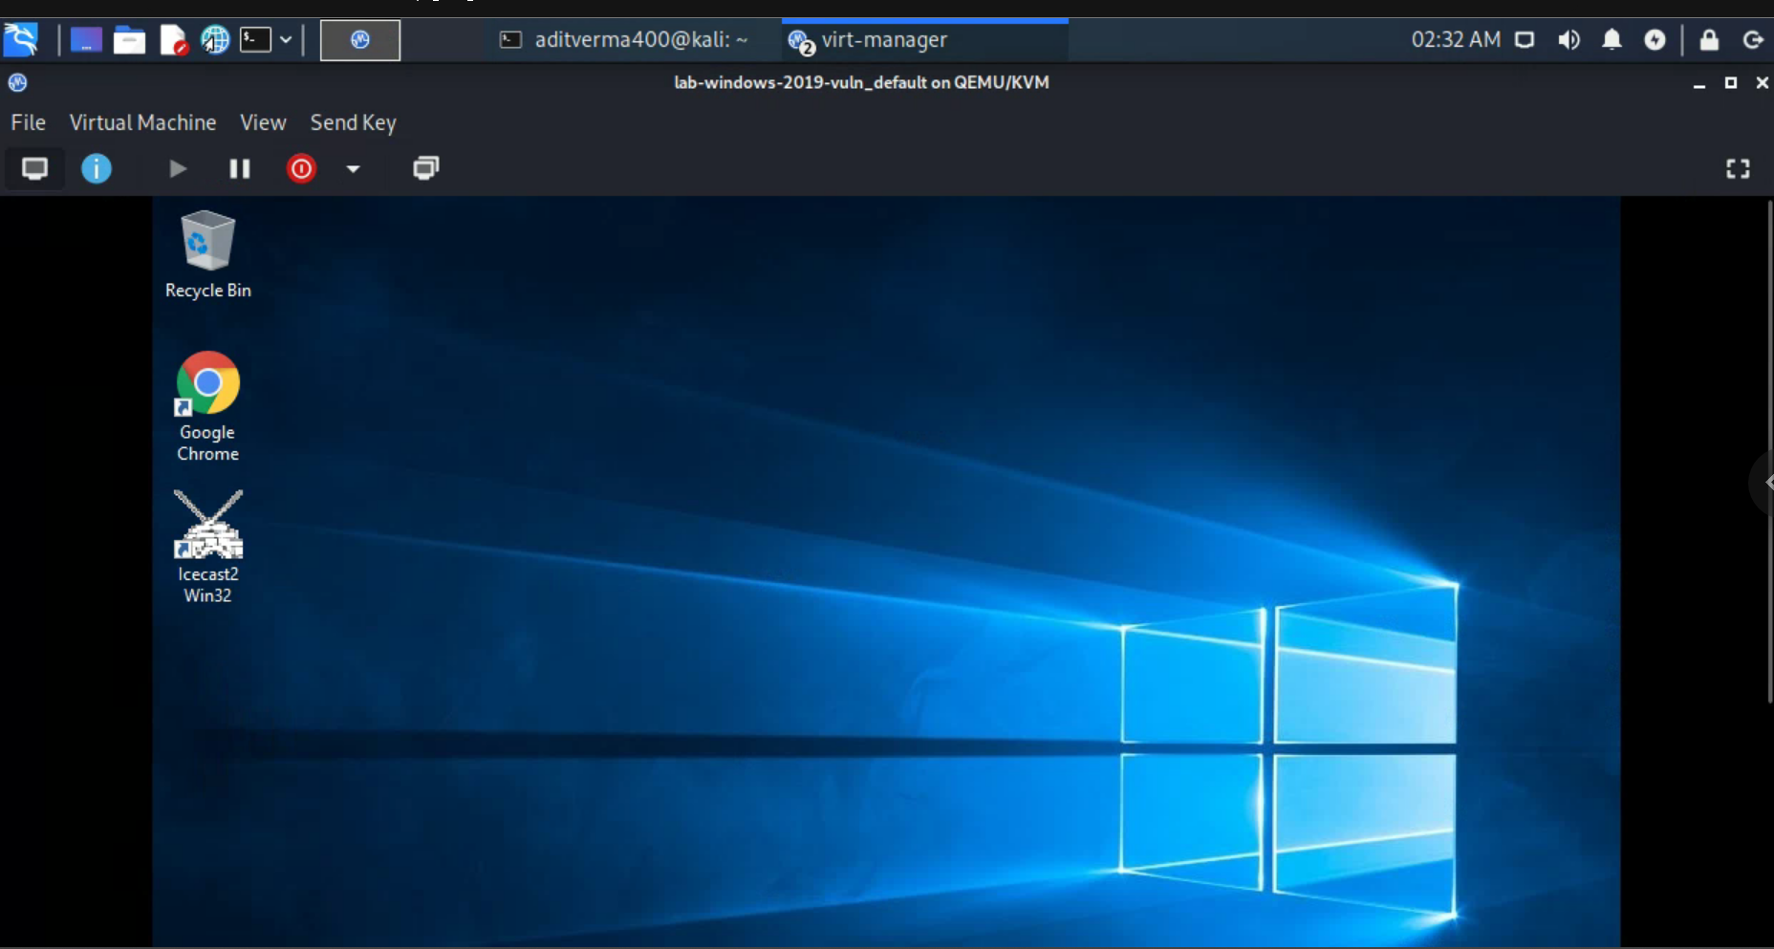

**Icecast with administrative privellages**

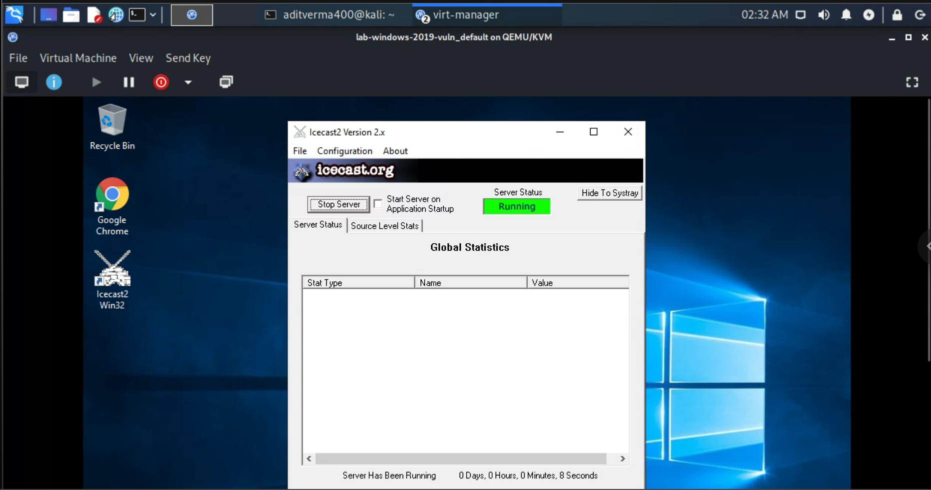

**Nmap version scan on windows**

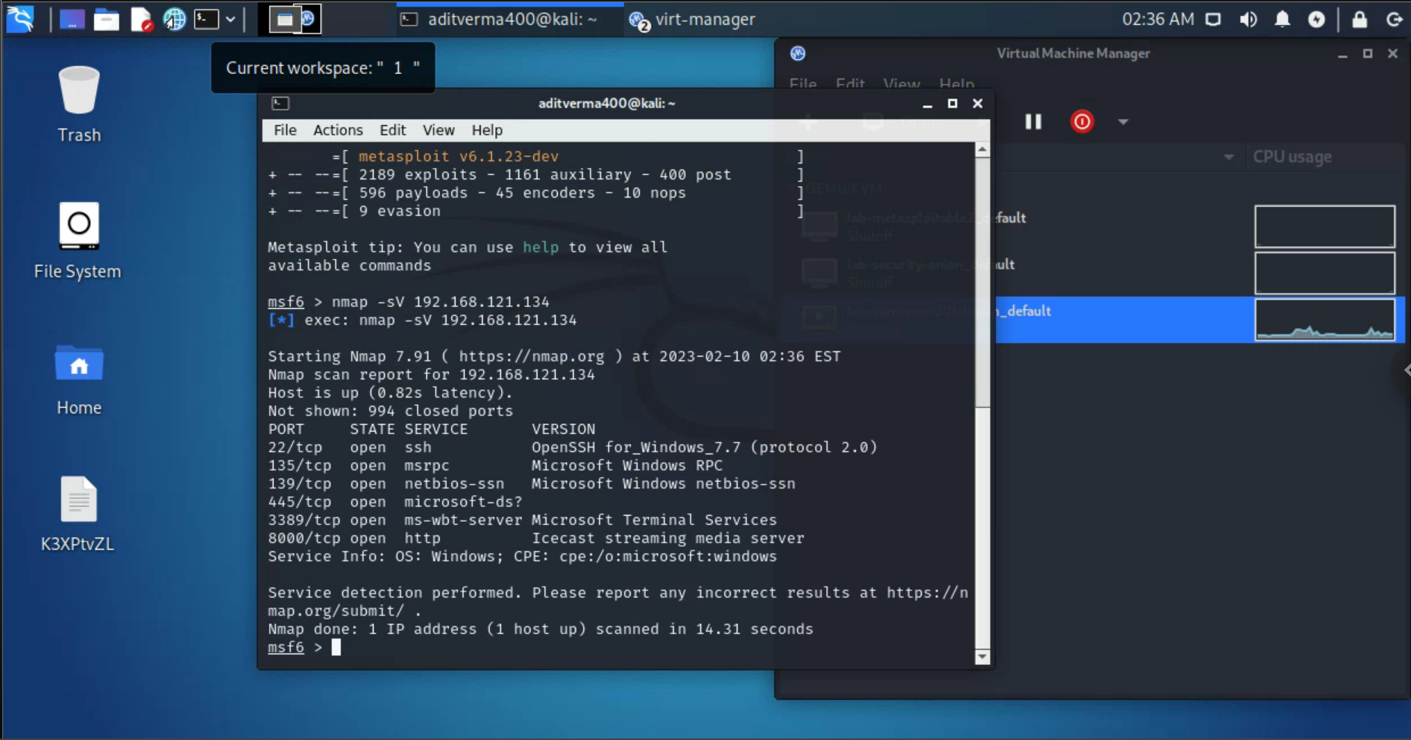

**Finding the icecast vulnerability and exploiting it**

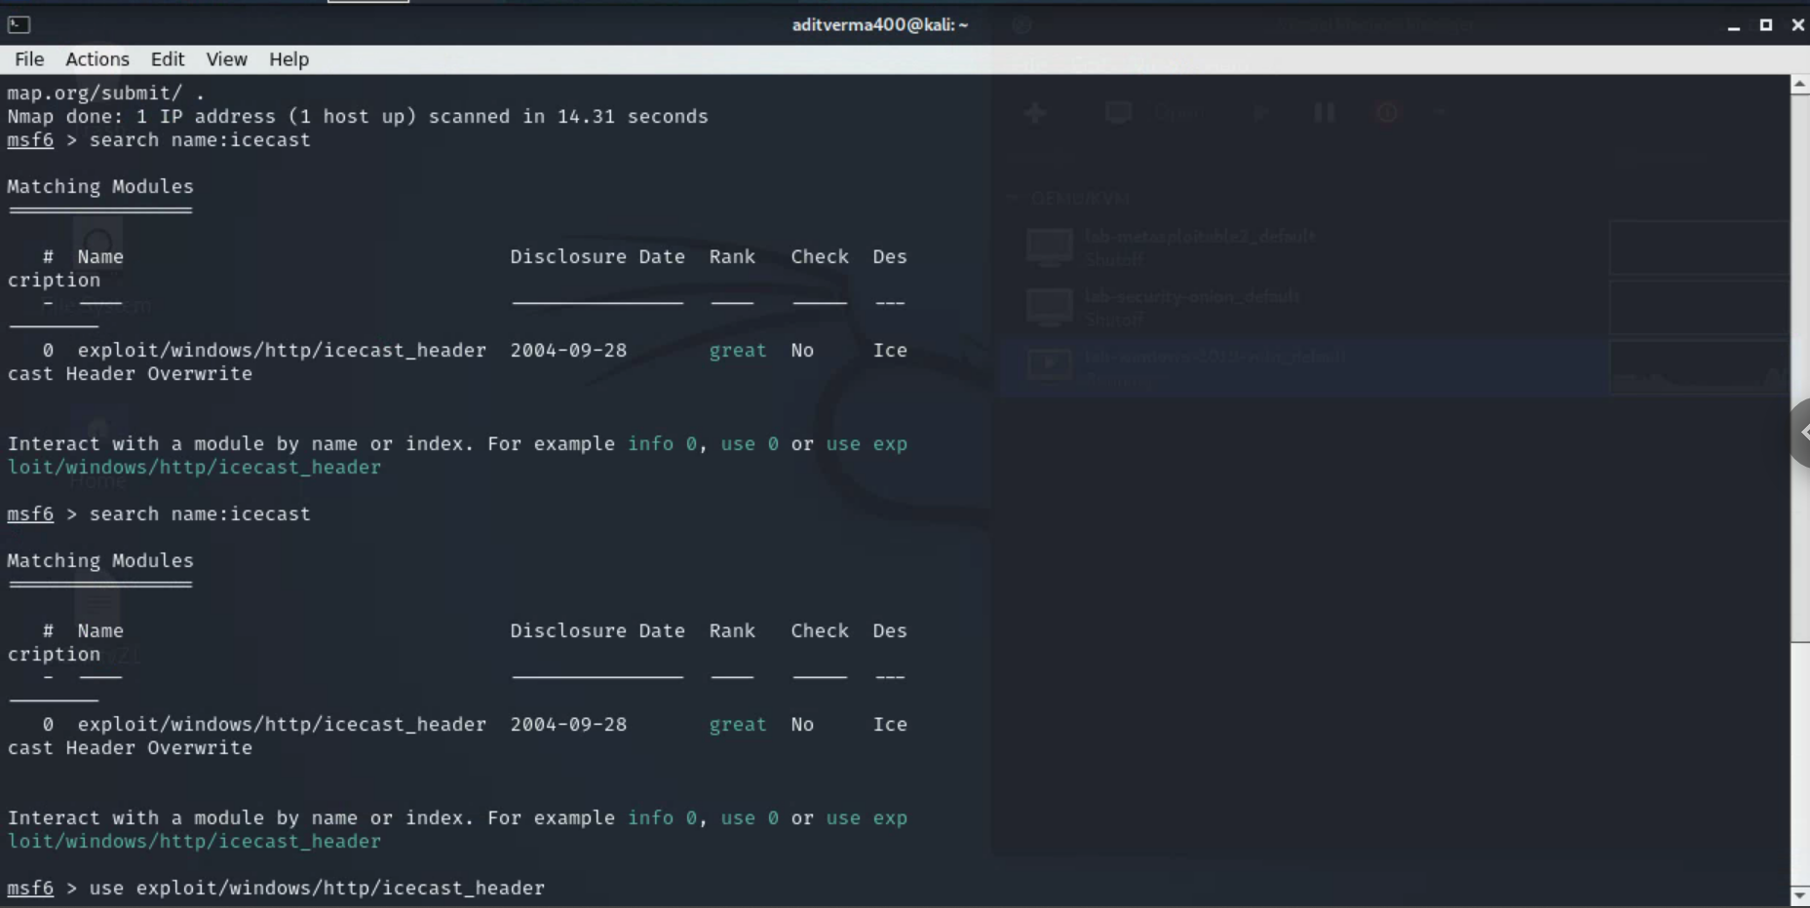

**Setting the host and port**

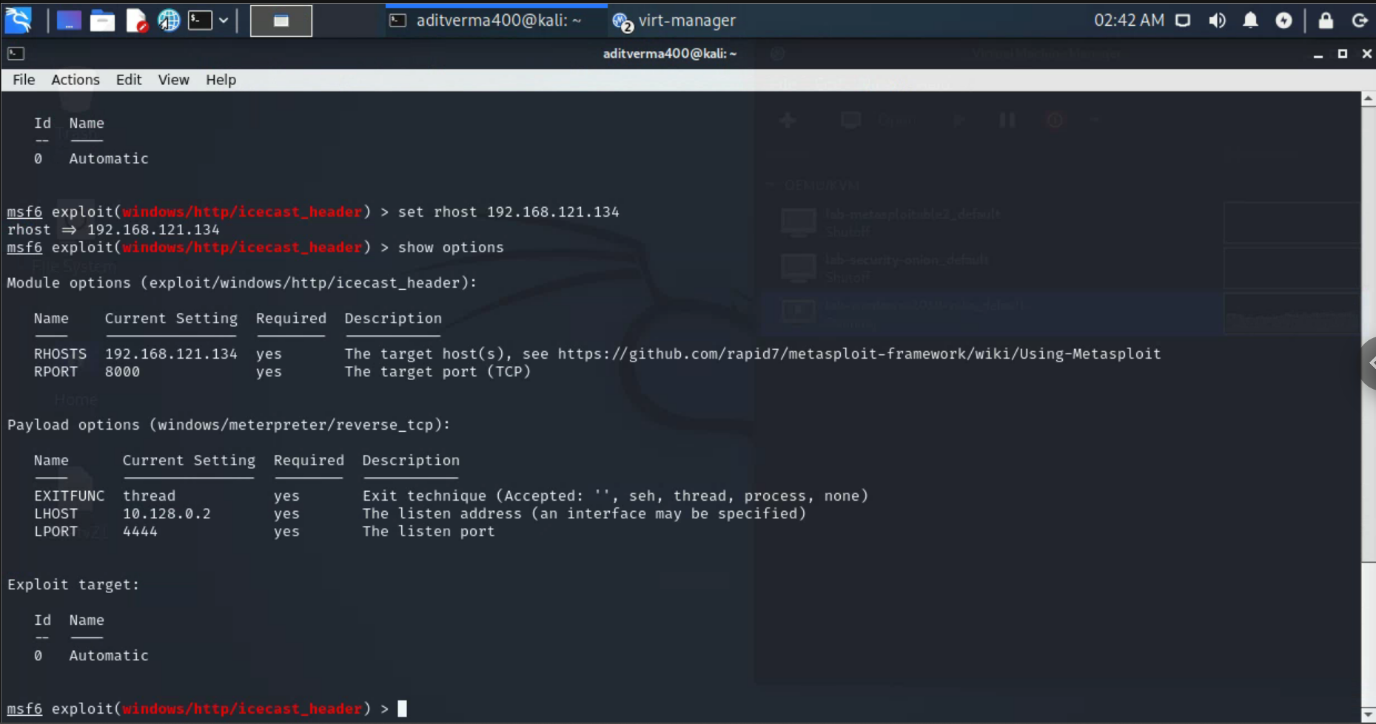

**Saving all the configurations and exploiting**

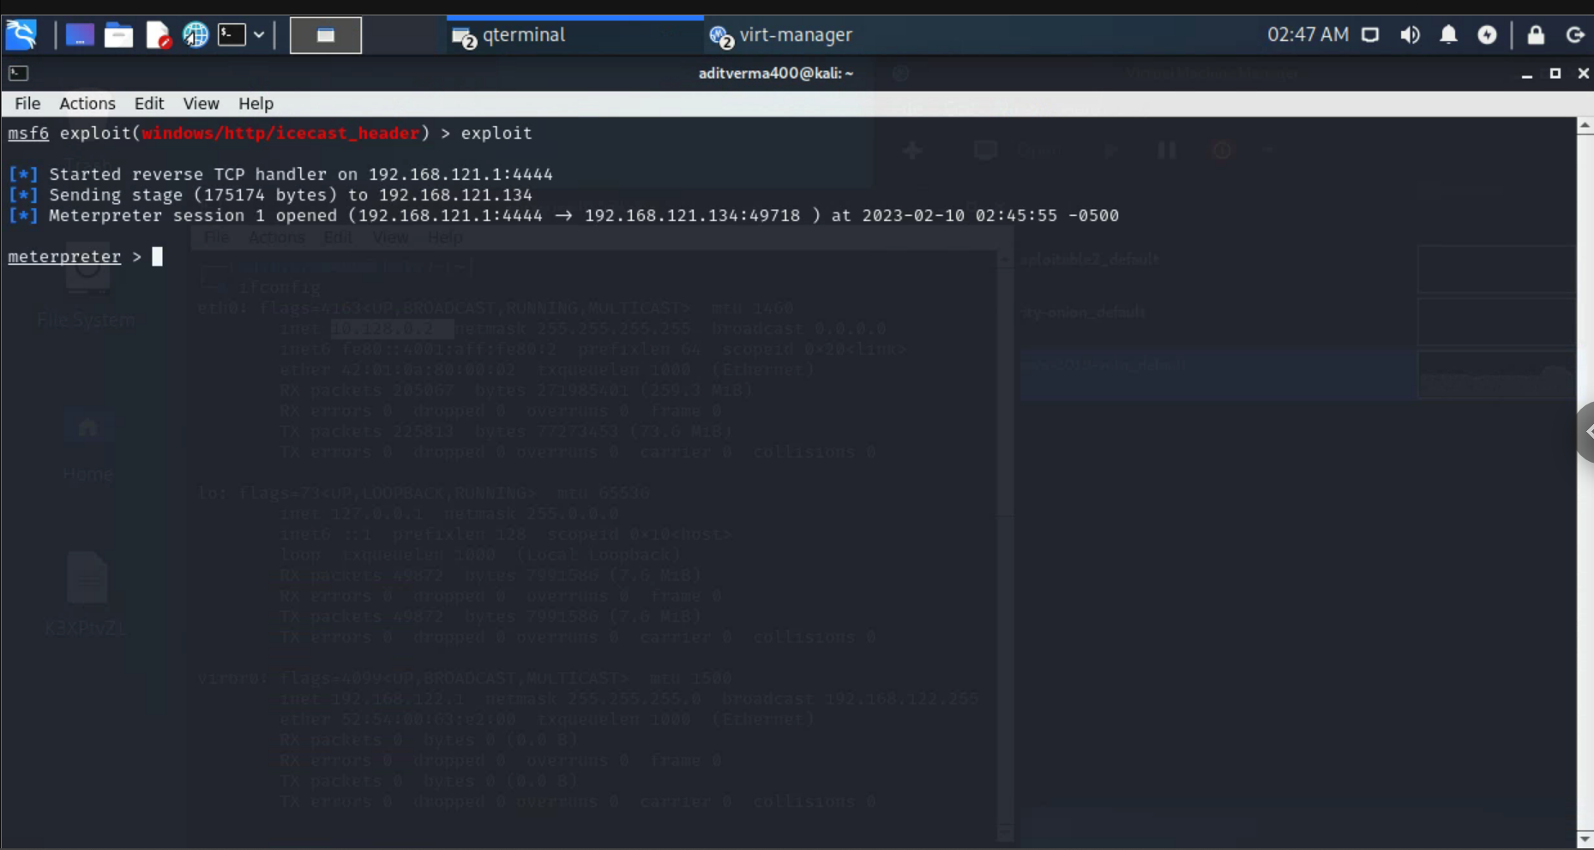

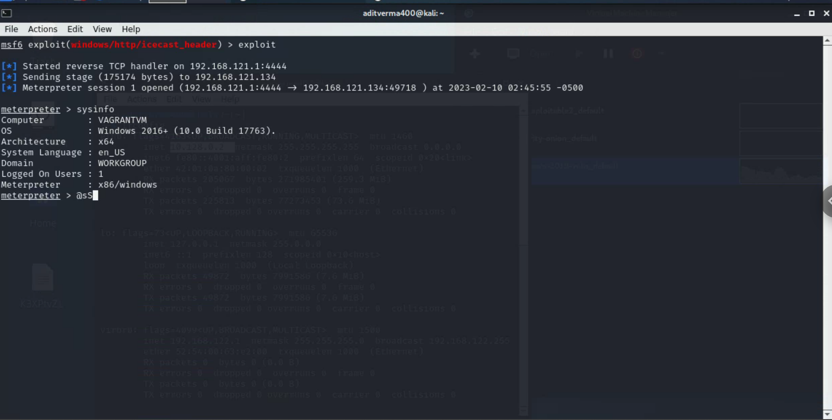

**Disabling the antivirus**

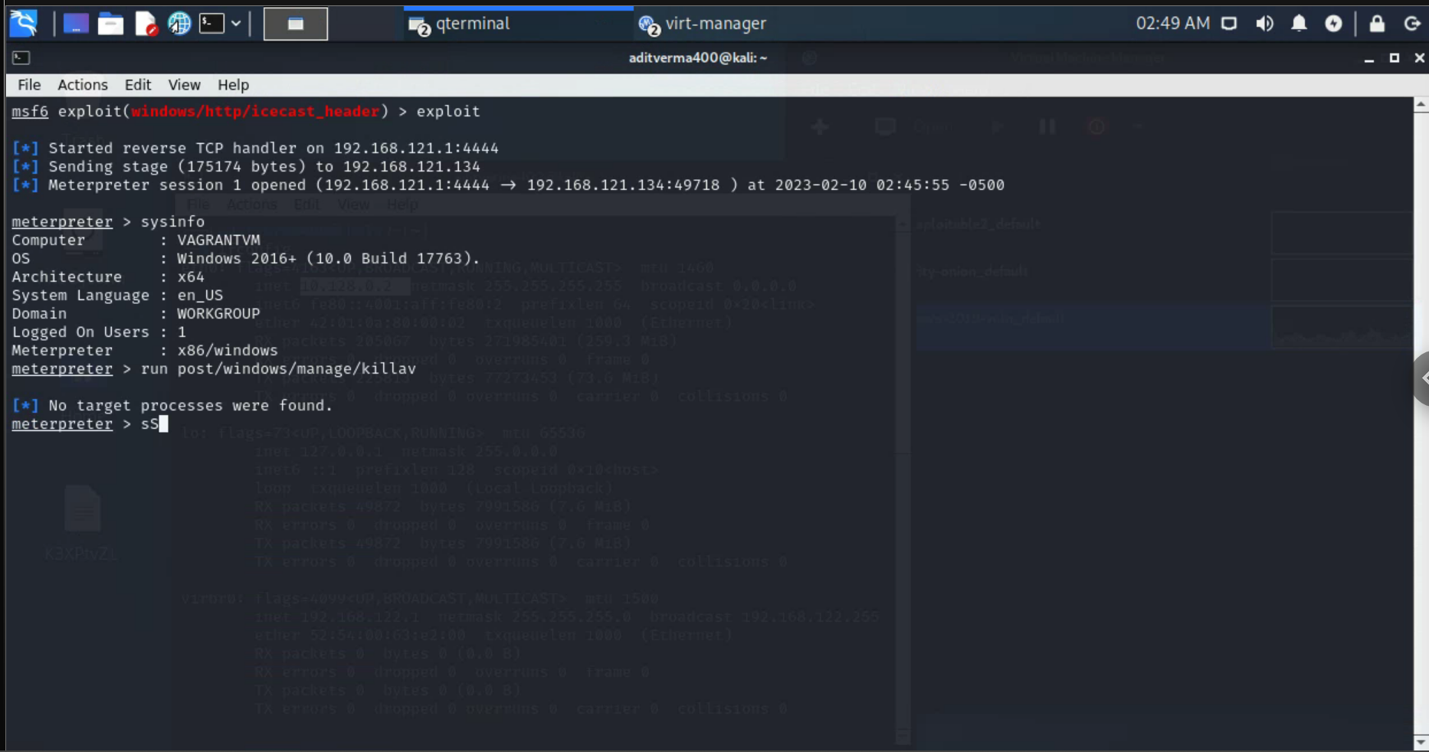

**Windows instance screeshot form the vm**

**/home/aditverma400/suaGzrSm.jpeg**

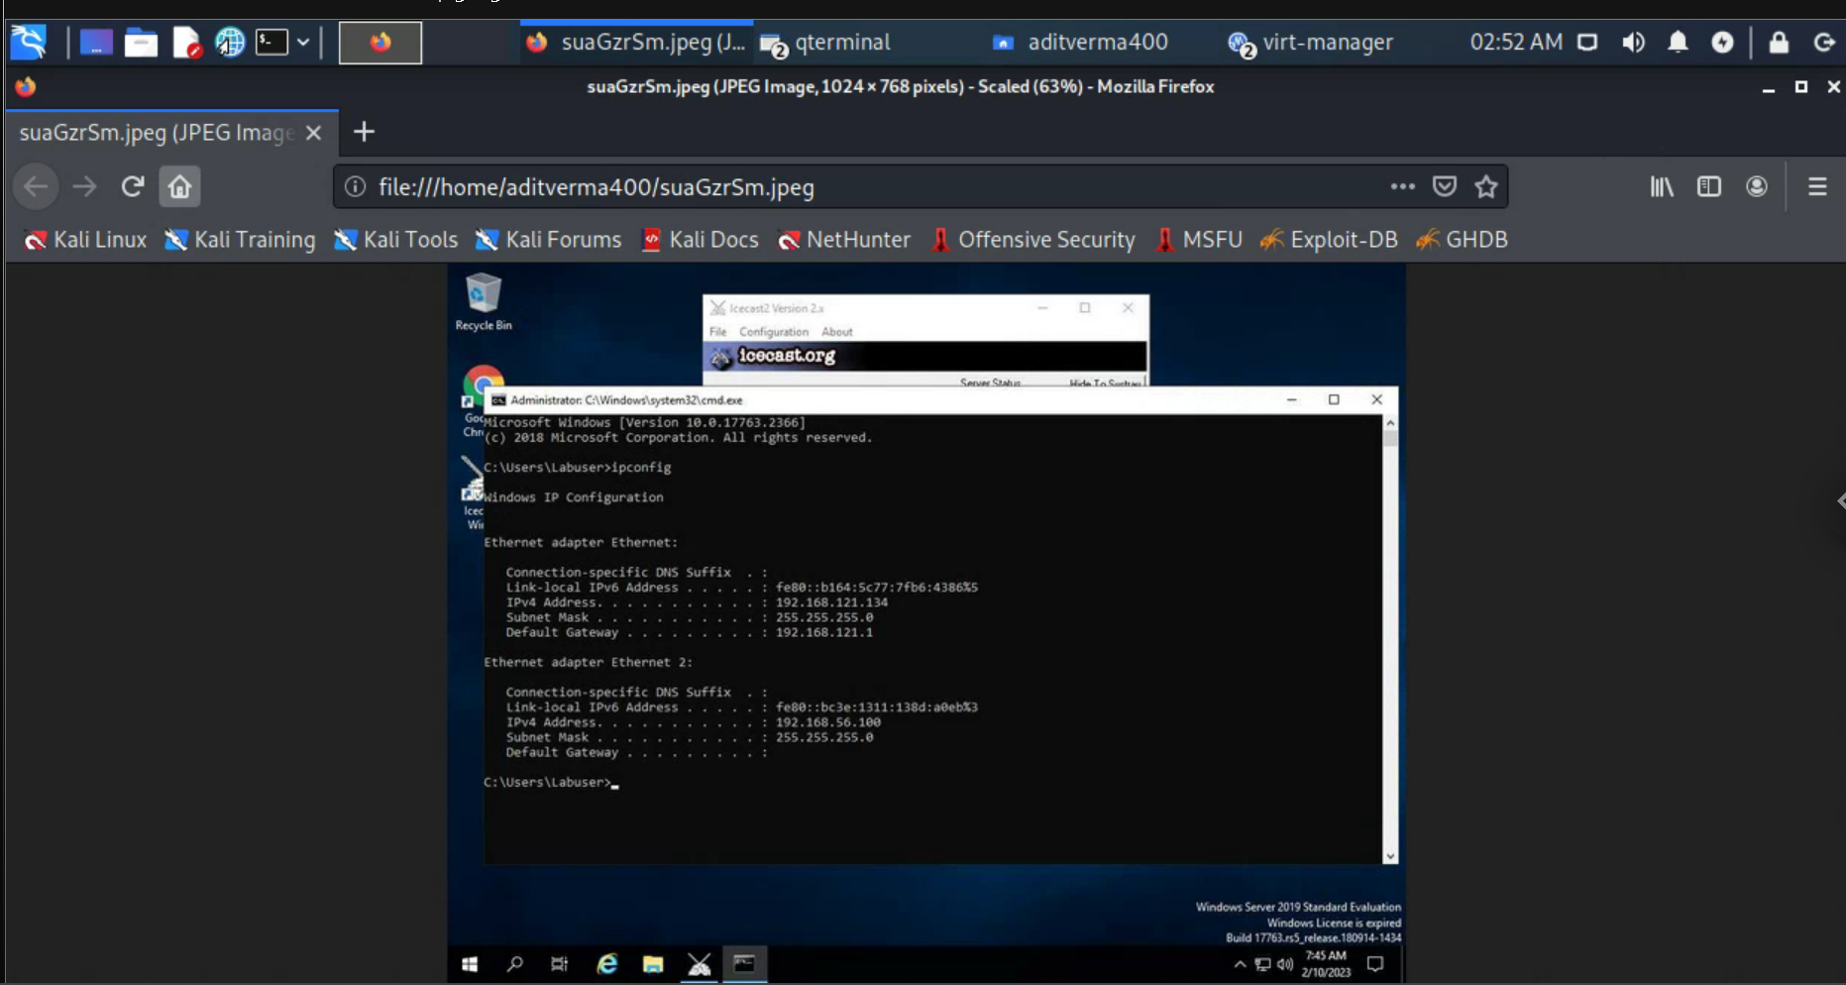

**Using the vnc payload**

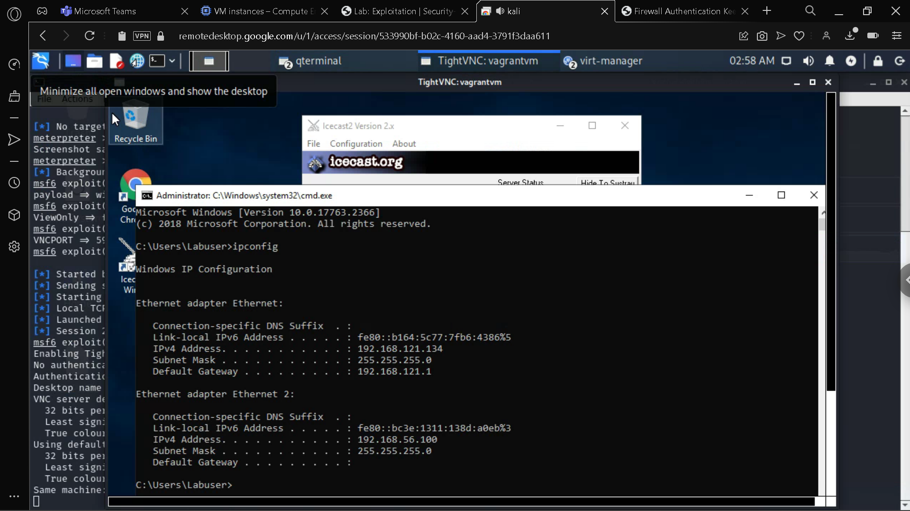

**Stealing Hashes**

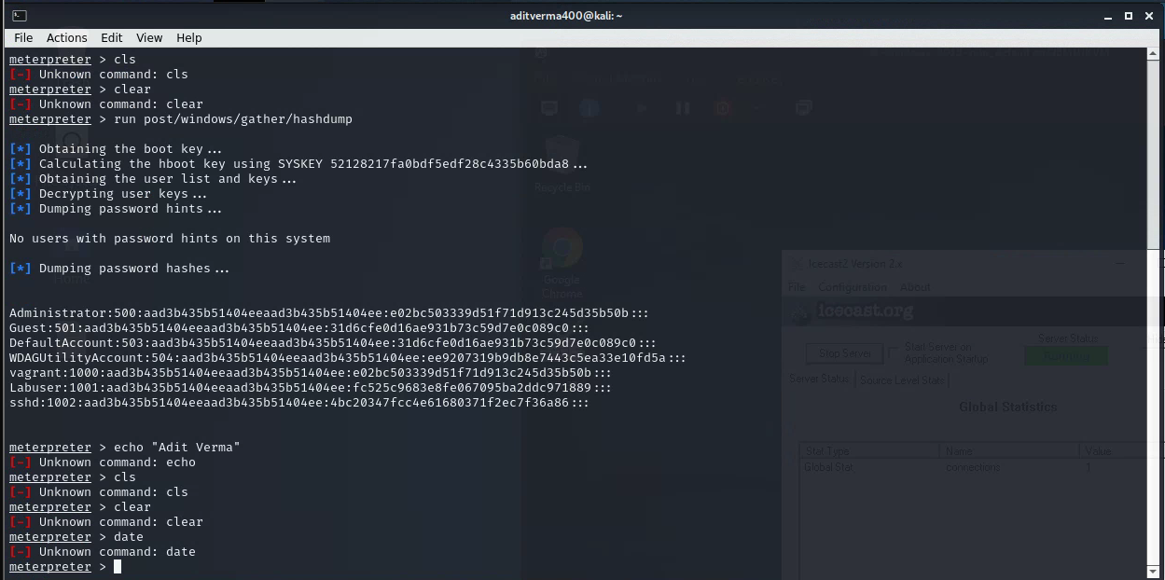

**Starting with metasploitable2**

**Running the nmap scan**

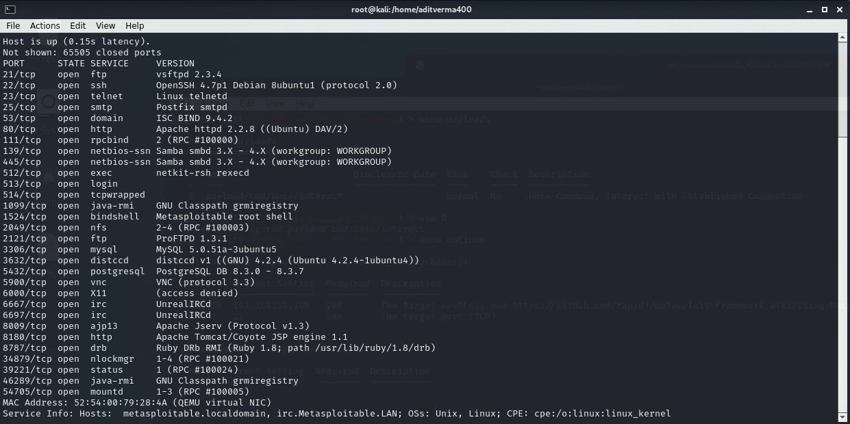

**Getting the basic shell**

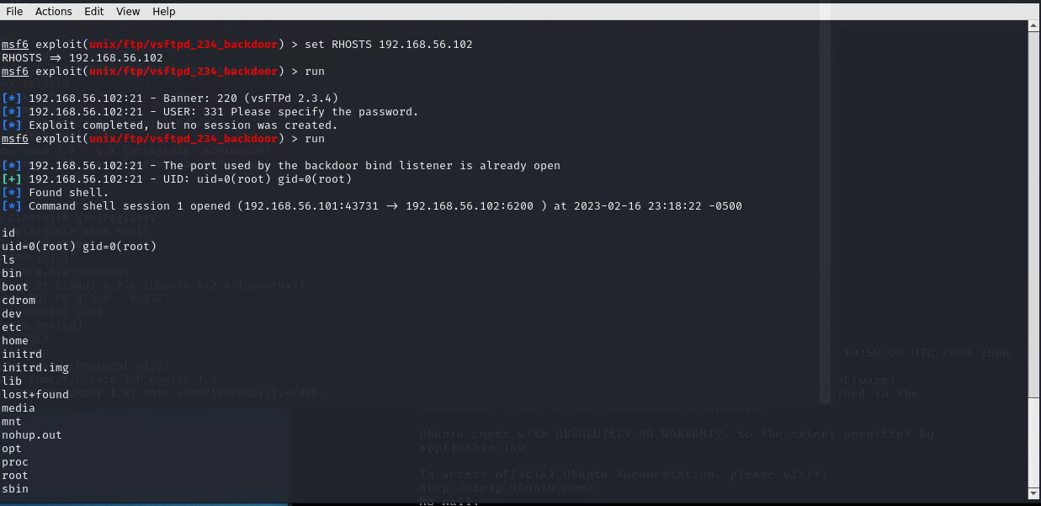

**Getting meterpreter form the basic shell**

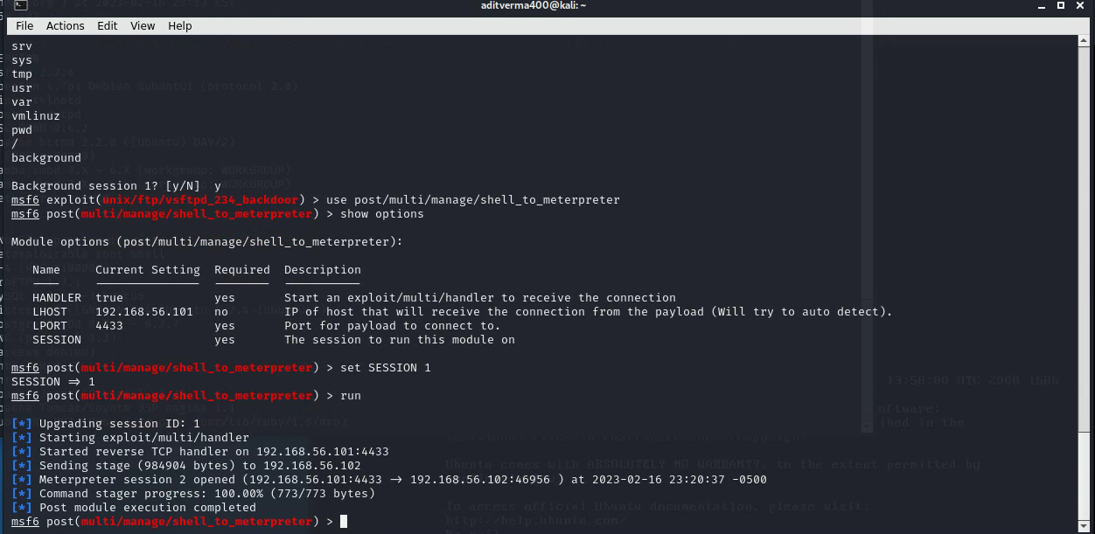

**Getting the usernames and passwords**

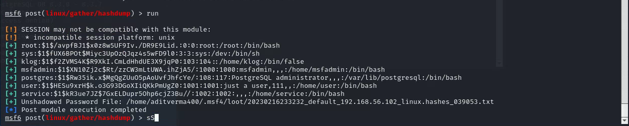

**Question-Answers –**

**Question 1:**What is the NTLM hash of the user vagrant?

1. **The hash for the the user vagrant is :**  vagrant:1000:aad3b435b51404eeaad3b435b51404ee:e02bc503339d51f71d913c245d35b50b:::

Question 2: Submit a screenshot showing you running the phish_windows_credentials postmodule, the harvested username and password, then dropping into a shell and echoing your name and the current date (see example screenshot below)

A)

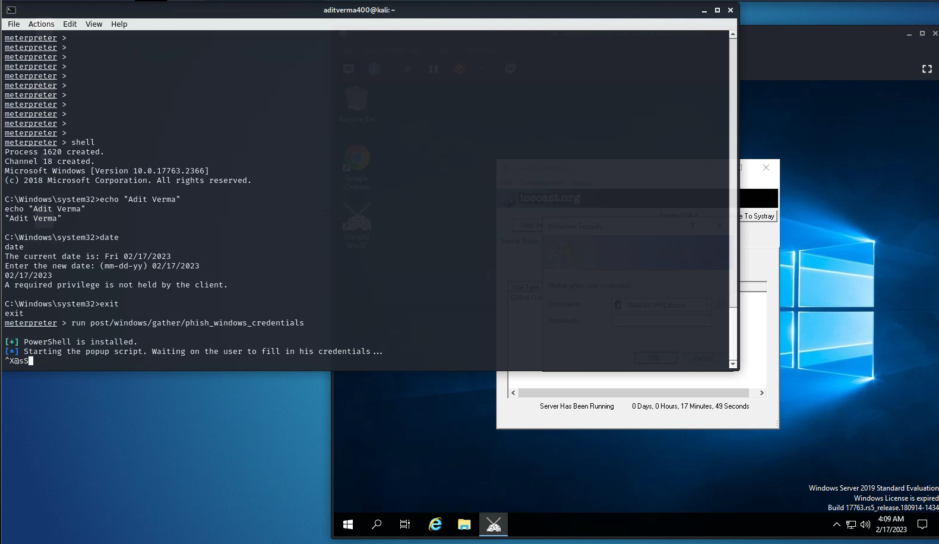

Question 3 : What is the salt and hash for the Postgres user?

1. postgres:$1$Rw35ik.x$MgQgZUuO5pAoUvfJhfcYe/:

Question 4 :

Exploit – 1

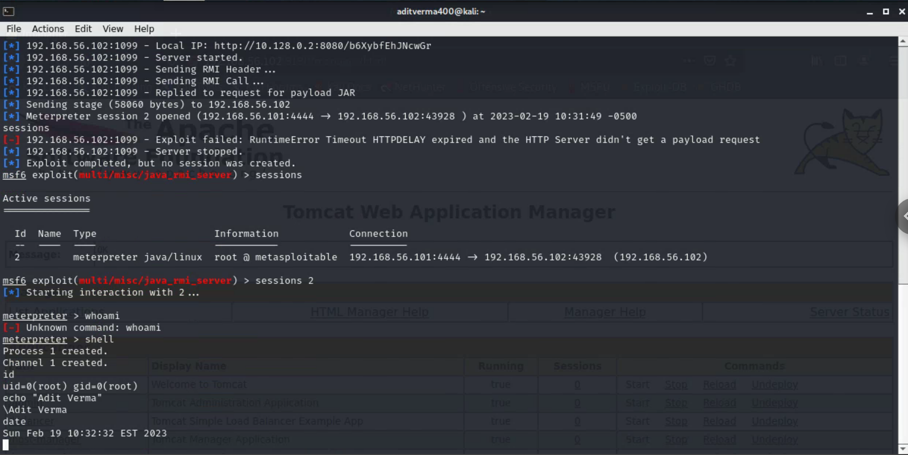

Exploit – 2

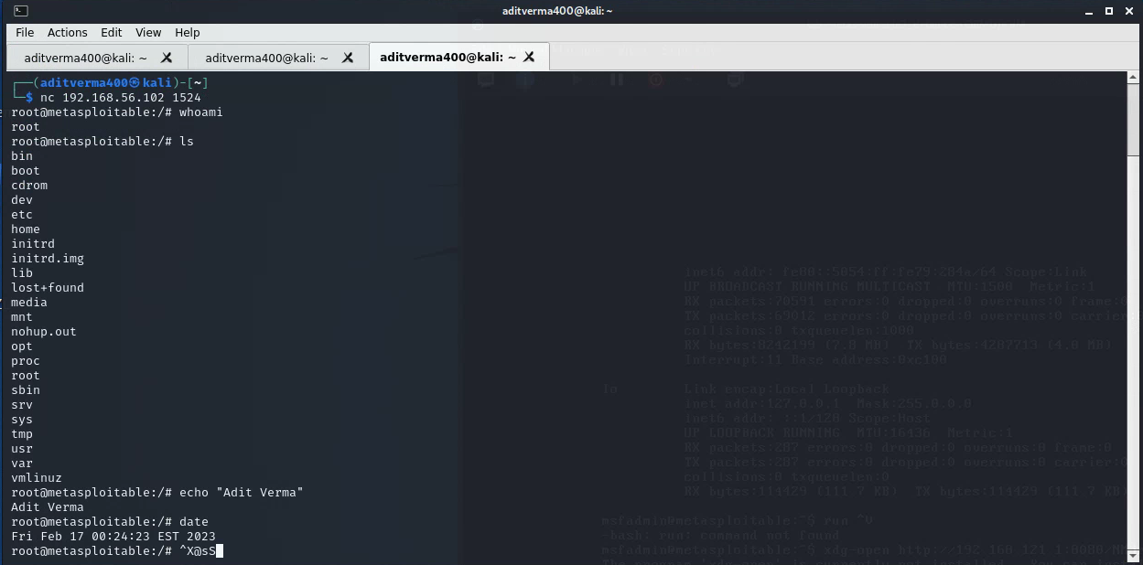

Exploit – 3

